**Harvard-Yenching Institute**

A Note on The So-called TLV Mirrors and The Game Liu-po

Author(s): Lien-sheng Yang

Source: *Harvard Journal of Asiatic Studies,* Vol. 9, No. 3/4 (Feb., 1947), pp. 202-206 Published by: Harvard-Yenching Institute

Stable URL: <http://www.jstor.org/stable/2717892>

Accessed: 24/05/2011 17:53

Your use of the JSTOR archive indicates your acceptance of JSTOR's Terms and Conditions of Use, available at <http://www.jstor.org/page/info/about/policies/terms.jsp>. JSTOR's Terms and Conditions of Use provides, in part, that unless you have obtained prior permission, you may not download an entire issue of a journal or multiple copies of articles, and you may use content in the JSTOR archive only for your personal, non-commercial use.

Please contact the publisher regarding any further use of this work. Publisher contact information may be obtained at <http://www.jstor.org/action/showPublisher?publisherCode=hyi.>

Each copy of any part of a JSTOR transmission must contain the same copyright notice that appears on the screen or printed page of such transmission.

JSTOR is a not-for-profit service that helps scholars, researchers, and students discover, use, and build upon a wide range of content in a trusted digital archive. We use information technology and tools to increase productivity and facilitate new forms of scholarship. For more information about JSTOR, please contact [support@jstor.org](mailto:support@jstor.org).

|  |  |
| --- | --- |
|  | *Harvard-Yenching Institute* is collaborating with JSTOR to digitize, preserve and extend access to *Harvard Journal of Asiatic Studies.* |

A NOTE ON THE SO-CALLED TLV MIRRORS AND THE  
GAME *LIU-PO "AlS*

LIEN-SHENG YANG

HARVARD UNIVERSITY

Numerous Han mirrors bear in their central zone a pattern of straight lines resembling the Roman letters T, L, and V; and, for convenience, have been called " TLV mirrors " by modern students of art. For the last thirty years scholars have been puzzled by the significance of this pattern.

On Han stone bas-reliefs, notably those in the tomb-chambers of Wu Liang's family in Shantung, we find more than one repre­sentation of people sitting about a board which also bears lines in the TLV pattern. Various attempts have been made to inter­pret this board, and consequently also the TLV pattern. Among the more prominent interpretations are: a magic board (LAUFER) , a plate or tray of food (CRAvANNEs) , a chess-board (NAKAYAMA Heijiro) , and the instrument of divination which is called *shih* 4, or *ch,`ih (KAPLAN) 1*

The resemblance between the pattern and the board on the Han reliefs was established as early as 1919, when NAKAYAMA Heijiro 411114c4d15 reproduced in one of his series of articles on ancient Chinese bronzes four of these reliefs' In his article, the Japanese scholar prefers to call the angular form in question a chess-board, but also carefully admits that it may be the board of a similar game. YETTS, quoting NAKAYAMA indirectly from GOTO Moriichi's &Ulf work,' simplifies the suggestion to " it might be a chess-board imported from the West." 4

1 B. LAUFER, *Chinese Grave-sculptures of the Han Period,* 1911, 35; E. CHAVANNES, *Mission archeologique dans la Chine Septentroinale,* 1913, 1.184; NAKAYAMA Heijiro, see footnote 2; S. M. KAPLAN, On the Origin of the TLV Mirror, *Revue des arts*

*asiatiques,* 11.1 (1937). 21-24.

*Kiikogaku Zasshi* A-t,*140,t,,, 9.8 (1919). 34-45. *Kanshikikyo* M4ft, 1926, Toky5, 35.

W. P. YETTS, *The Cull Chinese Bronzes,* 1939, London, 149.

In 1938 and 1939, the final solution seemed to have been found when KARLBECK and YETTS almost simultaneously developed the sun-dial theory.5 The earlier theories have since been practically discarded. However, in view of some recently published Han (or San Kuo) mirrors, the theory that the TLV pattern is related to a chess-board or rather to a game-board, should now, I think, receive fresh consideration.

In UMEHARA Sueji's *Selected Ancient Mirrors Found at Shao­hing Tombs* 6 &Eg*it :1614-611AM, a mirror is shown on which we find four immortals playing at a board which closely resembles that on the Han bas-reliefs and the TLV pattern (see Plate I) . One immortal has in hand a big cup shaped like the western dice-box. Another holds a few sticks, apparently for record-keeping. All four seem to be excited about the game. This section of the mirror bears the four-character inscription, *hsien-jen*

fl iJ " immortals playing the game *liu-po."* Unquestionably this label offers a key to the whole problem. UMEHARA misreads

the character *po* as fu and thus fails to make any important comment.

From this mirror-inscription, it may be concluded that the people on the Han reliefs are playing a game, and that that game is *liu-po.* It is not unlikely that the TLV pattern of the Han mirrors was borrowed from the *liu-po* game-board—a game at which the immortals were frequently represented as playing. By this device the mirror might be presumed to be endowed with the ability to give its owner an enjoyable life like that of an im­mortal. This reassertion of the game-playing concept does not necessarily disclaim the sun-dial theory; the design of the board may perhaps have been derived from that of. the sun-dial.

The game *liu-po* appears in the poem *Chao hun f64 by* SUNG Yii 53 in the third century B. C. When the poet describes the enjoyments of this world in order to entice a certain soul (sup­posed to be that of Oa Yuan ) ra) to come back, the game is mentioned in lines that may be rendered as follows:

Orvar KARLBECK, *Catalogue of the Collection of Chinese and Korean Bronzes at Hallwyl House, Stockholm,* 1938, Stockholm, 25-30; W. P. YETTS, *op. cit.,* 148-165. 1939, KyOto Plate 6 (Reproduced hi this article as Plate I) .

" With bamboo sticks and ivory draughtsmen,

There is the game *liu-po.*

Dividing into groups and proceeding together,

Forcefully they threaten each other.

Having become *hsiao* (i. e., in the lead) and going

to win double,

One shouts for the five-white ' . . ."

Although there are lengthy commentaries on these lines by WANG I (first half of the 2nd century) and HUNG Hsing-tsu  
MOIL (1090-1155) ,7 and although there are many references to this and similar games,' the method of playing *liu-po* cannot be reconstructed with certainty. According to YEN Chih-t'ui tAt. 4ft,9 there were two kinds of *po* in ancient times, the *to-po*

using six *chu* and *hsiao-po* 4•113 using two dice called *ch'iung*

But to his knowledge, nobody knew how to play either game in his time (i. e., the latter half of the 6th century) . Now most Han writers agree that *liu-po* was played with six *chu* and twelve *ch`i* 44. The word *ch`i* means draughtsmen which are also known as ma Zi . The word *chu* however is puzzling. In some cases it seems to denote long sticks, perhaps like the ones on our mirror, and also known as *chien ;* but in other cases it denotes only small bamboo pieces to be thrown like dice.11 Perhaps the meaning has changed in different periods or with different methods of playing.

The cup-shaped box that is held by one of the immortals on

*pu-chu* mow, *(Ssil-pu tiling-lean* ed.) 9.15b-16b.

Mostly collected in the *Ku-chin teu-shu 1-shu tien* t+ffiSta,

0.11.1. 807.1a-21a. A careful study of the Chinese references **in** addition to a thorough research on similar games in other countries may throw light on the history of communications between East and West. Tv Ya-ch`iian's *Po shih *±MR,I4 k,* 1933, Shanghai, has made a good start on the Chinese side.

*9 Yen-shih Chia-hsiin MANE-011, (Pao-ching tang* taal ed.) 7.15b.

10 Written a in several other works. For the various names of dice, cf. Crux Hsileh-shih le** (18th century), *Mu-chu hsien-hua leataja (Chao-tai tseung­shuitgft* 167), 2a-3b.

*" Han Fei tau 4P-T (Ssii-pu tseung-Van* ed.), 11.6b; *Hai-ching tsa-chi*

jugg, *(Pao-ching tang* ed.), **B.** 9a-b; and *Kuang-ya shu-cheng, Mitijk2 (Chi-fu tseung-shu* au ed.), 8A.22b.

the mirror suggests the use of a certain kind of dice; on the other hand, the long sticks may have been shaken out of it, as is done in one method of divination. According to sources quoted by HUNG Hsing-tsu," the dice used in this game had four faces, and either two pointed ends, or one pointed end like a teetotum 13 The faces were carved with lines; the side with two lines standing for " white " and that with three lines for " black." Presumably one and zero appeared on the two other sides. If this was the appearance of the die, the chance of throwing " five-white " with five dice must have been very small. If the die had only two sides, black and white, as the *wit-mu* * 14 are supposed to have had, the chance increases tremendously. The six-sided dice ap­peared in China probably not earlier than the third century.'

The game *liu-po* is traditionally taken to be very similar to the later game *shuang-lu* MN which is the oriental backgammon popular in China from roughly the 7th to the 11th century, and in Japan from roughly the 9th to the 12th century." But the game-board in the TLV pattern looks rather different from a

"In PAO Hung's *Po-ching* fri1,rkst46, quoted by Huivo Hsing-tsu in the *Ch`u­tsca pu chu,* 9.16a, we read the following description of the die: " The face carved with one line is called *sai* a, 'blockade, barrier,' that with two lines ' white,' and that with three lines ' black.' A blank face between wu A five' and *sai* is called *wu-sai."* This text, however, may be corrupted. If the die was a top with four faces, the character wu, which appears twice in the same line, probably should read *san*

*"* three." Thus we have 0, 1, 2, 3, on the four sides. Another tenable hypothesis is that the top or die had six faces, standing for 0, 1, 2, 3, 4, 5. Thus zero could appear between five and one, i. e. *sai.* Tu Ya-ch`fian in his *Po-shili* reconstructs the die as having five faces, but he forgets that a five-faced top is unsatisfactory and a five-faced die is impossible. (I owe thanks to Dr. C. S. GARDNER for his very helpful discussion on this point.)

" For illustrations of a six-sided Chinese teetotum and four-sided dice with pointed ends (called in India *pare,* pl. of *pasa),* cf. Stewart Cw.IN, Chinese Games with Dice and Dominoes, *Report of National Museum,* Washington (1893). 496, 533. 14 Probably first mentioned by MA Jung *a* (79-166 A. D.), in his *Shu-p`u* fu Rai., *(I-wen lei-chii* 53Z$0, 74.22a-b). For a discussion on the Wu-mu *eking* A2Kfg, a Tang treatise on this dicing game, cf. E. D. EDWARDS, *Chinese Prose Literature of the rang Period,* 1937, London, 1.197-199. Also cf. *Po shih,* 7, 23-24.

*"Po shih,* 7-8.

*"Cleu-tz`ii pu-chu,* 9.16a; *Po shih,* 8-11; CleIEN Tao-sun gm-4 : 13 *ffir* " On Japanese Backgammon," *CHHP,* 102 (1935). 475-481.

*shuang-lu* or backgammon board, and we cannot yet ascertain how it was used. The four T's, four L's and four V's may indicate positions of the twelve draughtsmen.

That immortals played the game is recorded in a few Han and earlier works.11 The famous third century poet TS'AO Chih *Wah* writes, " Immortals hold six *chu* and play the game at the foot of 'raj Shan." 18 On several mirrors in this book by UMEHARA,19 we note that the deity Tung-wang-kung *E& also indulged in this game. A board, a dice-box, and three playmates may even be recognized as part of his iconography.

The game is traditionally supposed to be played by two people." But from this series of reproductions of mirrors, the four immortals seem to be playing partners. This partnership may be what is meant by the expression *fen-ts'ao 5+W "* dividing into groups " in the poem *Chao hun* quoted above.

17 *Ku-chin eu-shu chi-ch'eng, 1-shu tien,* 6a.

*" Tiao Tet-chien chi* w-Tgt, *(Ssii-pu ts`ung-Van* ed.) 62a. 19 UMEHARA Sueji, *op. cit.,* Plates 15, 24, 26, 29, 37, 53, and 61. *2° Ch`u-tz`ii pu-chu,* 9.16a.

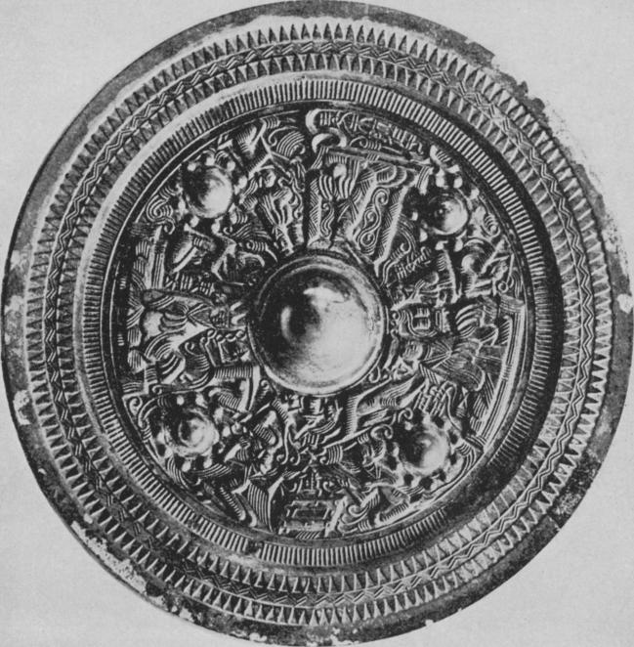

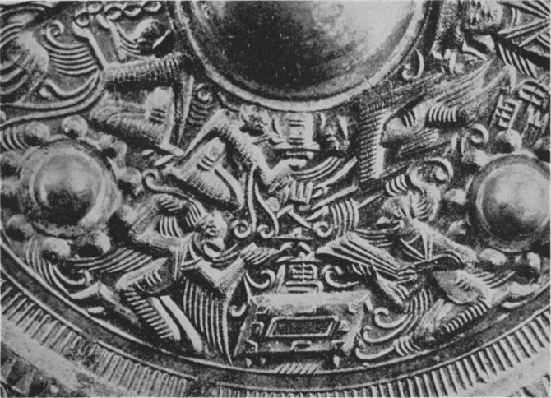

PLATE I

**MIRROR WITH FIGURES OF DEITIES**

U. Asano Collection, Osaka